

Project Report

price comparison website



December 10, 2021

Saad Ahmad

**Table of Contents**

1. **Introduction**…………………………………………….….2
2. **Report** **Content**…………………………………………...2

Project Description……………………………...2

Web scraping……………………………………….2

RESTful web service……………………………..4

Displaying stored data………………………….5

1. **Screenshots**………………………………………………...6

Front-end……………………………………………..6

Unit tests…………………………………………….11

1. **Database** **Design**………………………………………..11
2. **Limitations………………………………………………….**12

**Introduction**

This project aims to build a price comparison website for rooms available to rent in northwest London UK. This report contains detailed information regarding the technologies and frameworks used for web scraping and in generating the back-end and front-end of the website along with screenshots of the website, unit tests, and database design.

**Report Content**

Project description

The name of this price comparison website is ‘RentSmart’ where users can search for a postcode in northwest London and the resulting page would display all rooms available for rent with its monthly rent, description/address, and a link to view the original ad. Users can also click on the button ‘Display all rooms’ if they want all available rooms in NW postcode to be displayed. Clicking the ‘help’ button will display a modal page containing instructions for using the website. Users can move through the pages that display rooms using the forward and backward arrows at the bottom of the webpage. Furthermore, users can sort the rooms in ascending or descending order based on monthly rent.

Web scraping

* The code for scraping data is written in java using the IDE eclipse.
* The following websites are scraped:

1. Openrent - https://www.openrent.co.uk
2. Rightmove - https://www.rightmove.co.uk
3. Zoopla - https://www.zoopla.co.uk
4. Gumtree - https://www.gumtree.com

* The following data is scraped from each website:

1. Description/address
2. Rent (converted to monthly rent if required)
3. Image URL
4. Original ad URL

* Threads are used to allow the program to scrape from four different websites simultaneously.
* Four different classes are used to represent each website.
* JSOUP is used for web scraping with the help of CSS selectors to filter out the required data.
* The run function for each class that represents a website, uses a loop to scrape data from websites for postcodes between from ‘NW1’ and ‘NW11’
* The web scraping can be stopped if ‘stop’ is typed in the terminal window.
* Scraped data is stored in an SQL database using hibernate whereas spring is used to manage dependencies between different classes in the program.

RESTful webservice

The following two pictures are screenshots of the two different paths implemented for the RESTful API. The final screenshot is a just another case of the second path when the value of offset and postcode are changed.

Path: /rooms

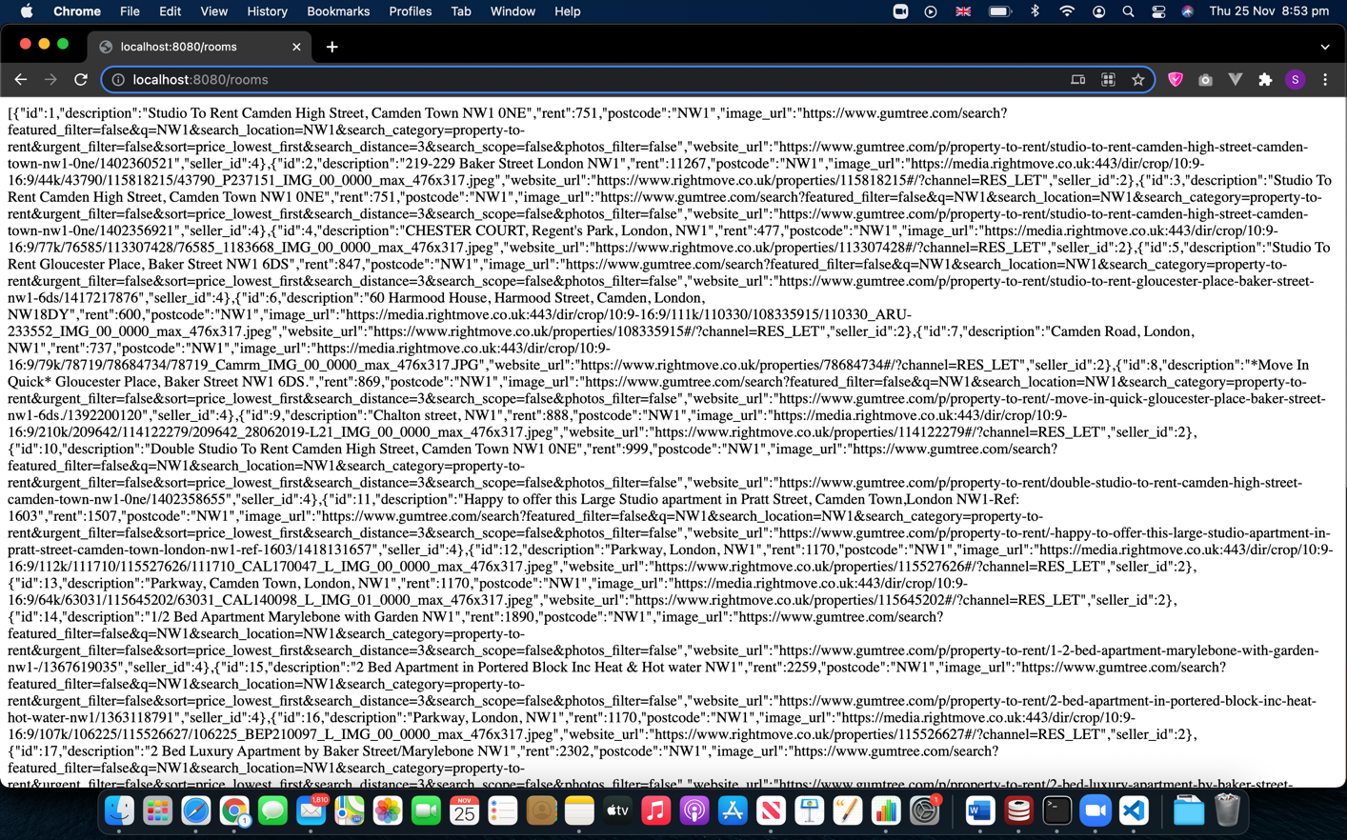

Path: /rooms/<postcode>?offset=<offset value>

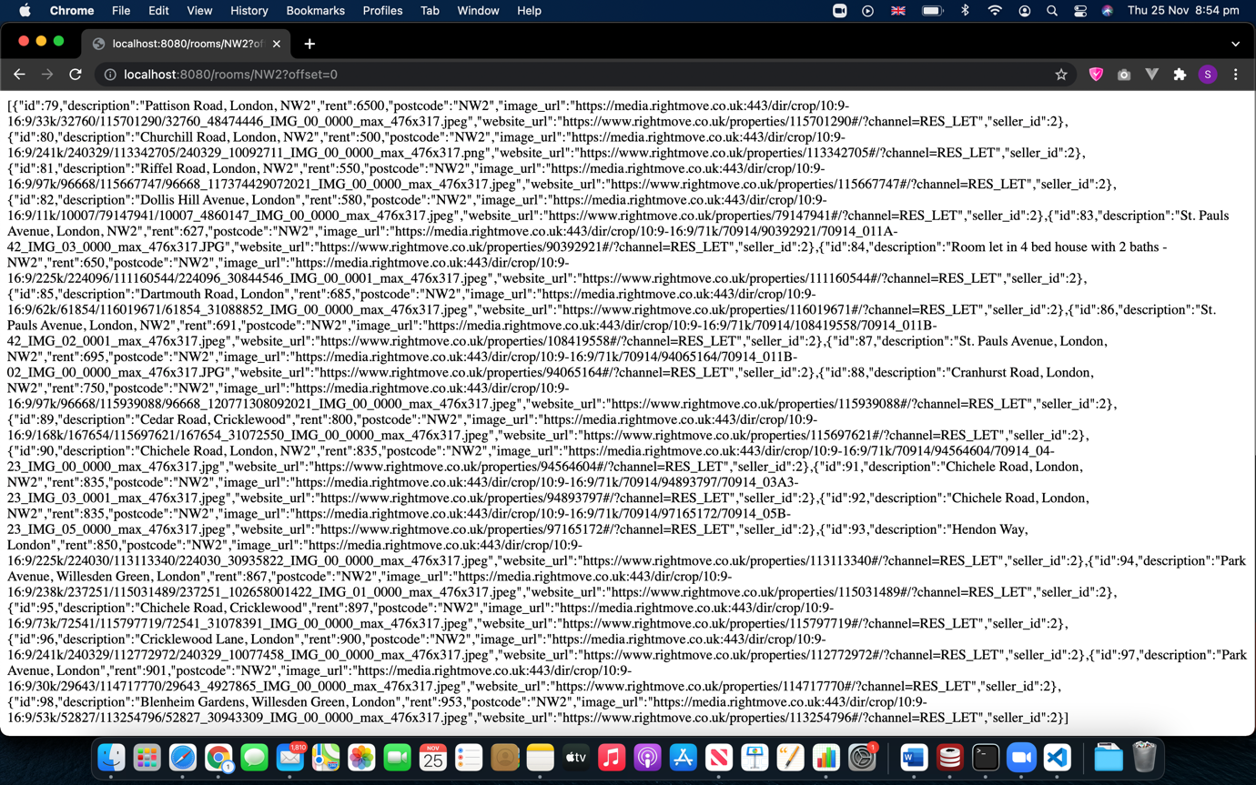

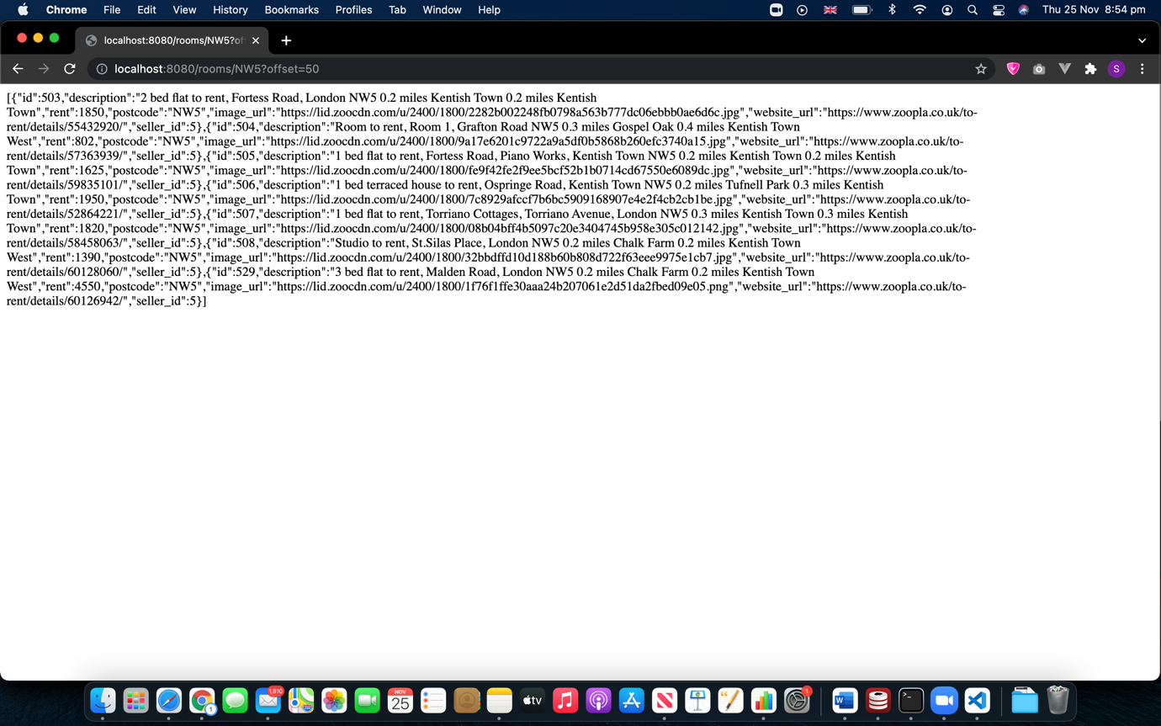

Displaying stored data

* Client-side and server-side code is written in JavaScript using visual studio code as the IDE.
* Node.js and express are used build the back end of the website.
* SQL query language is used to pull scraped data stored in the database.
* This data is then sent to the client-side using promise-based fetch API.
* At client-side, data is stored in an array and displayed using the Vue.js framework.
* Showing user’s searched value and the sorting functionality is also implemented with the help of Vue.js
* Bootstrap is used to make the website look more attractive and easier to use.

**Screenshots**

Front-end

Main page:

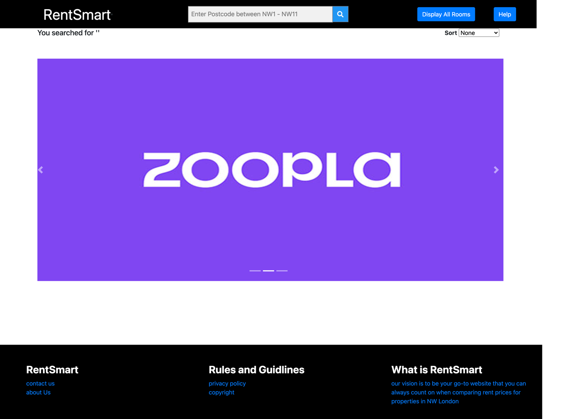

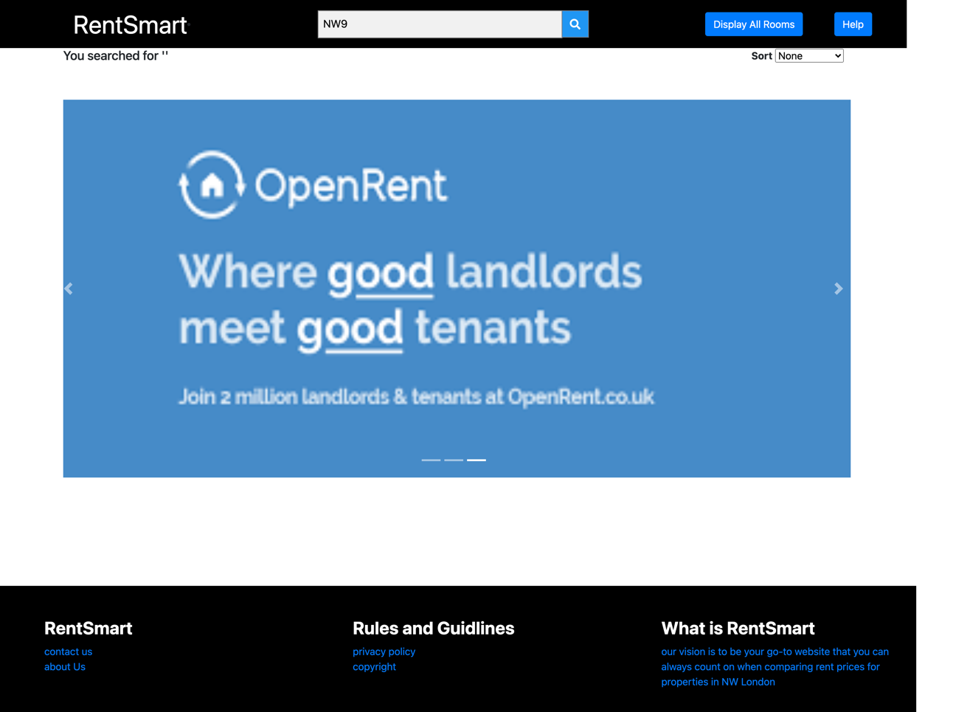

Search value = ‘NW5’

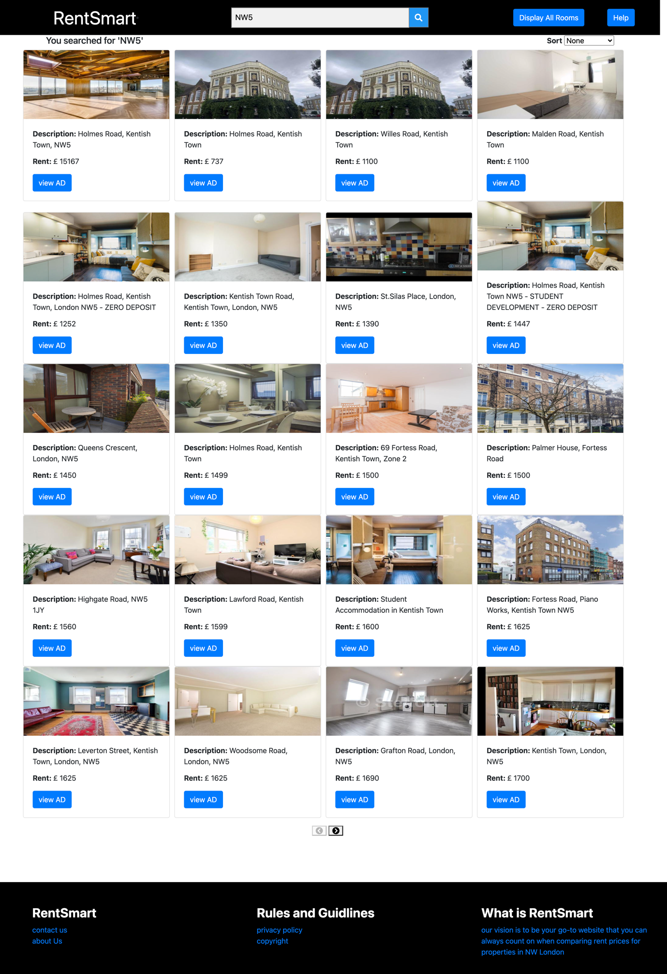

Sorting order = ‘Ascending’

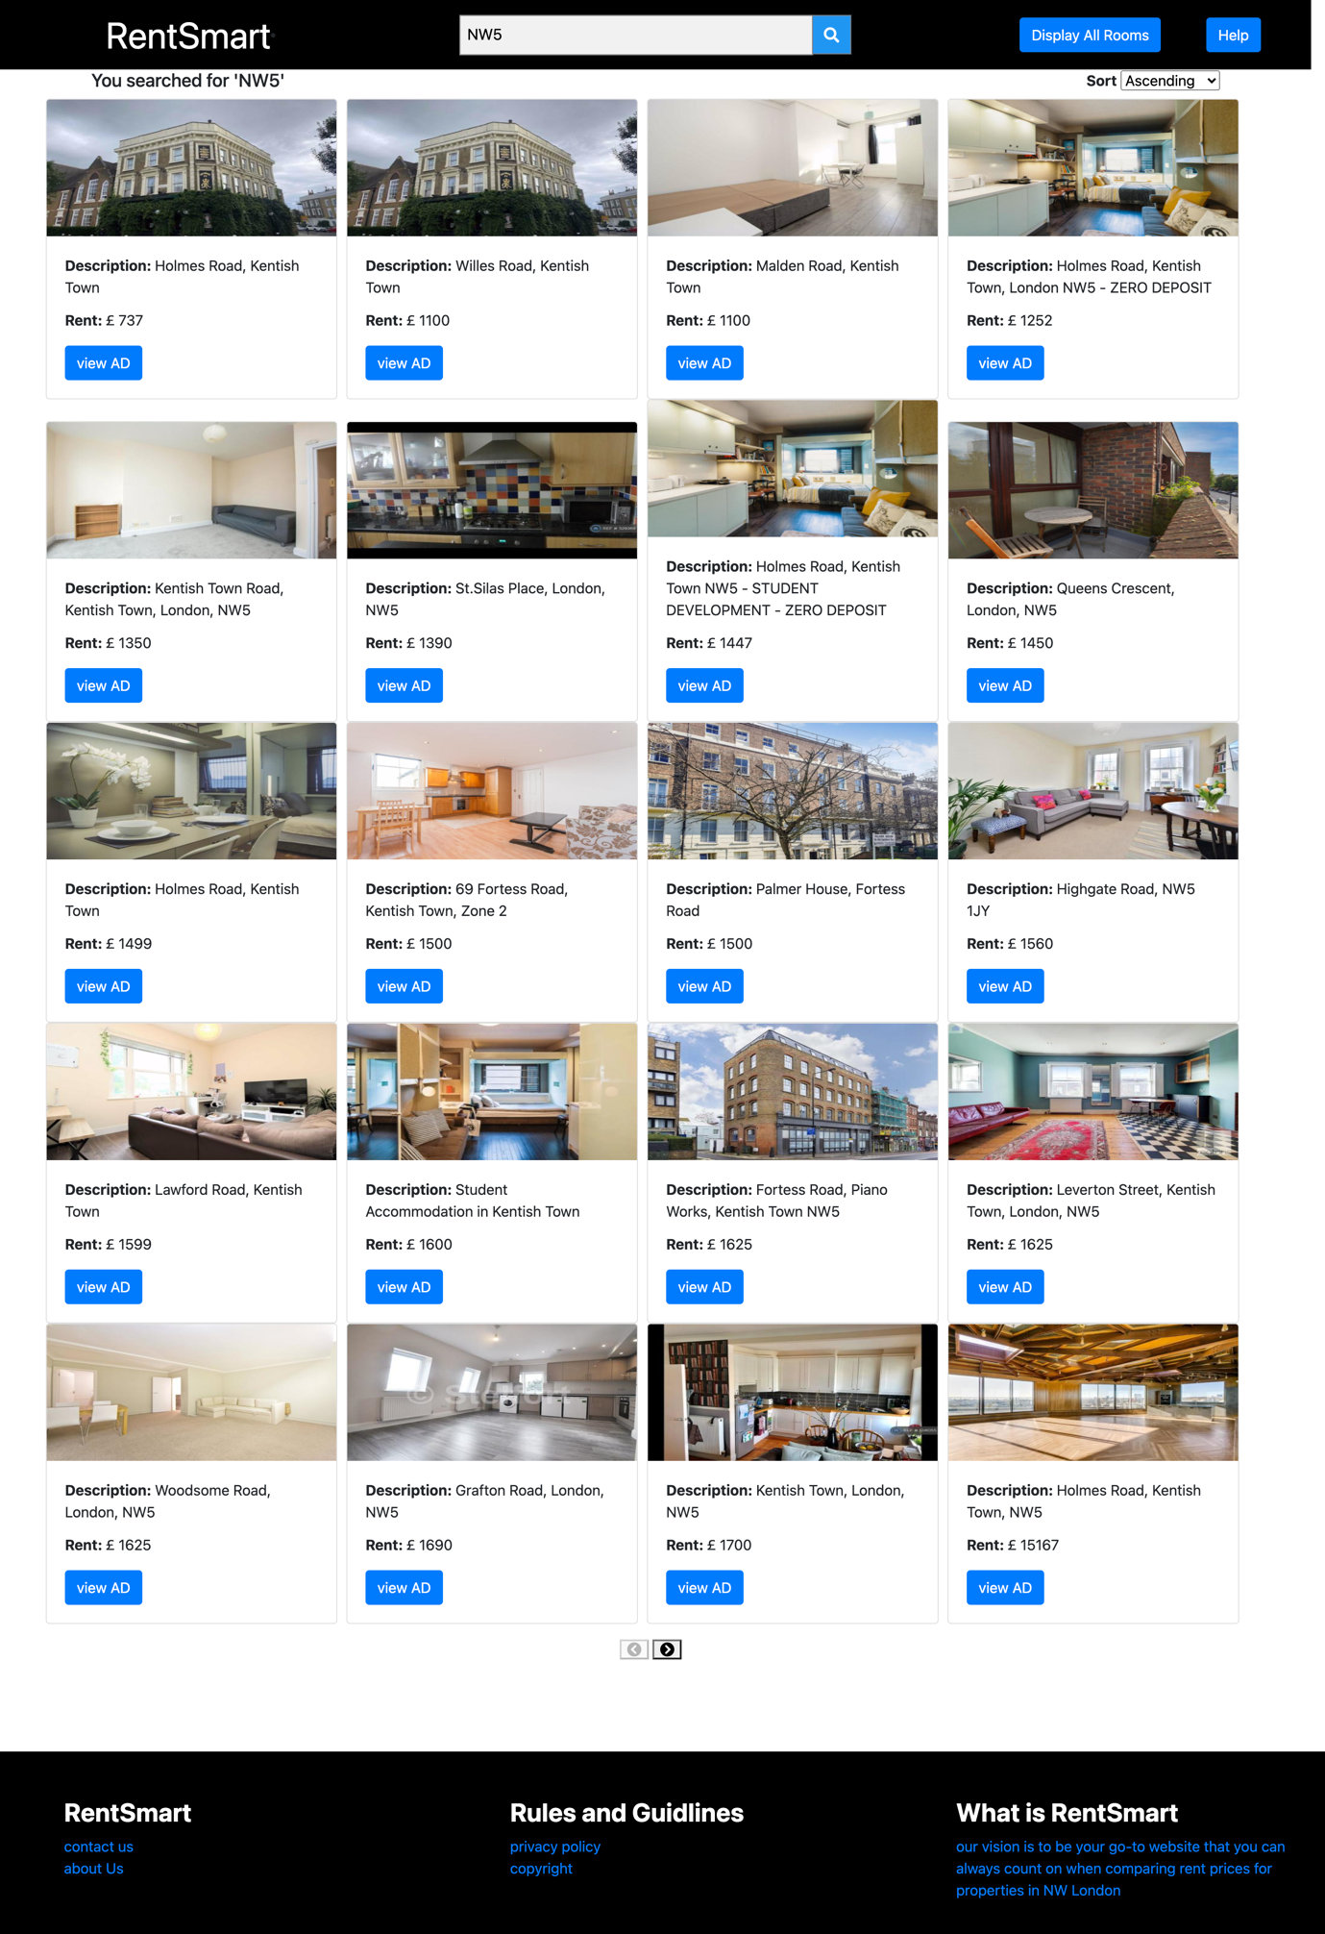

Sorting order = ‘Descending’

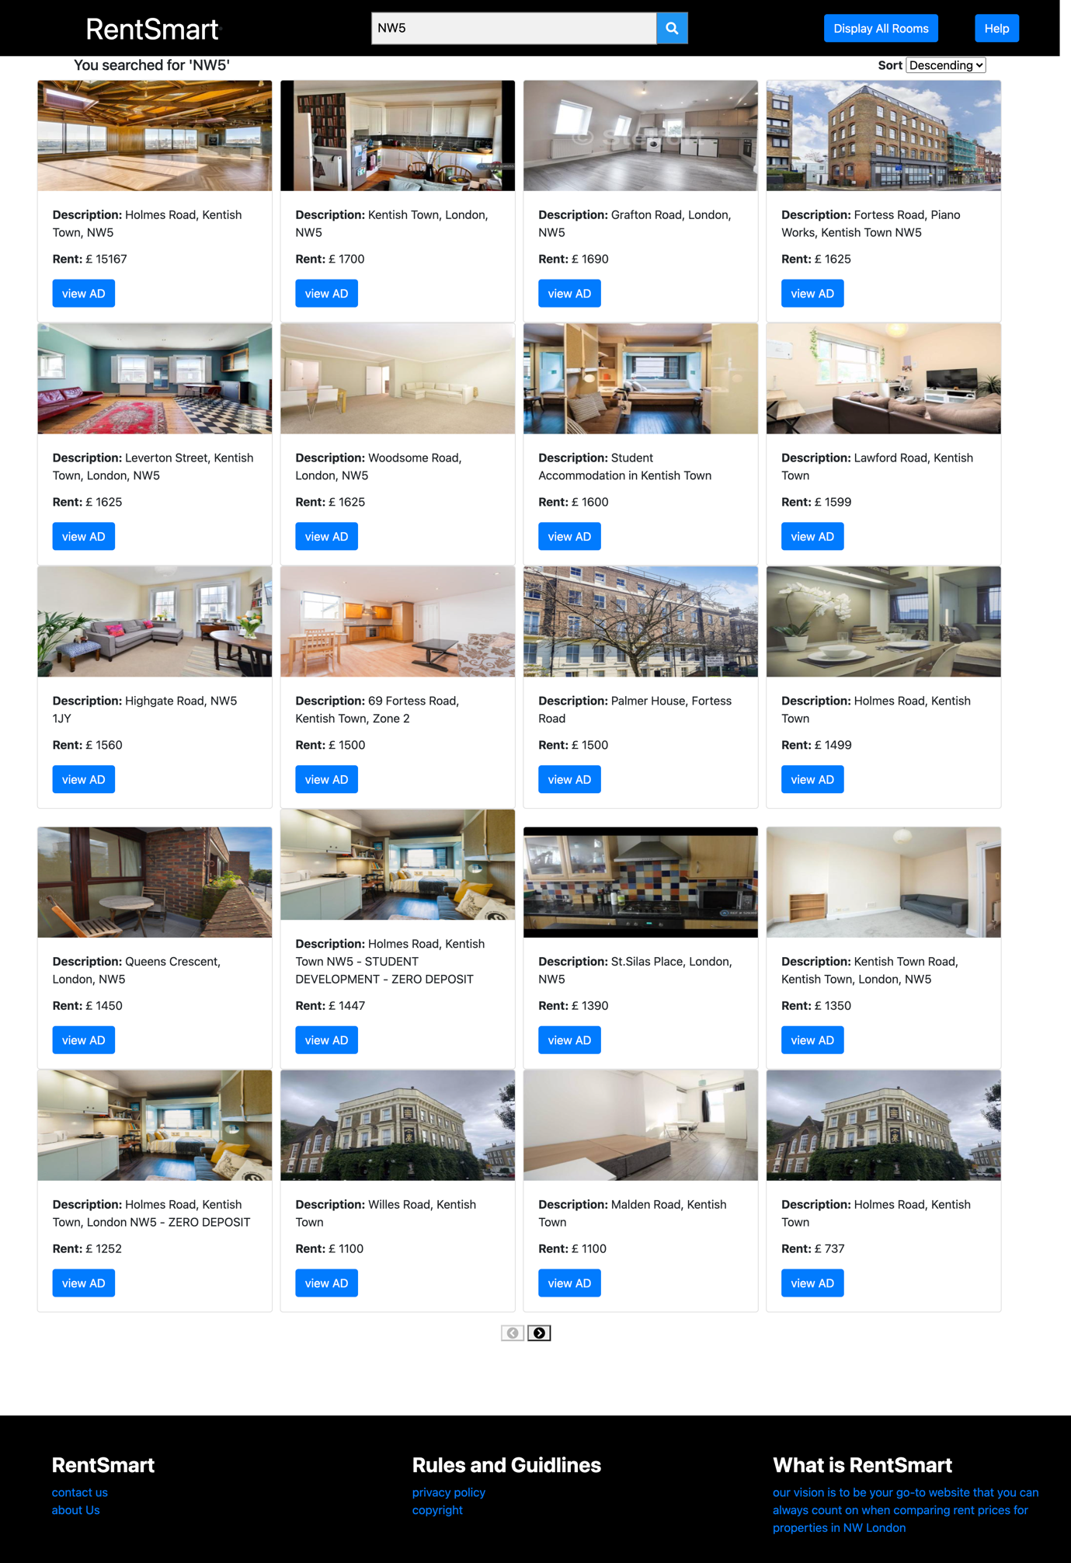

Last page when search value = ‘NW8’

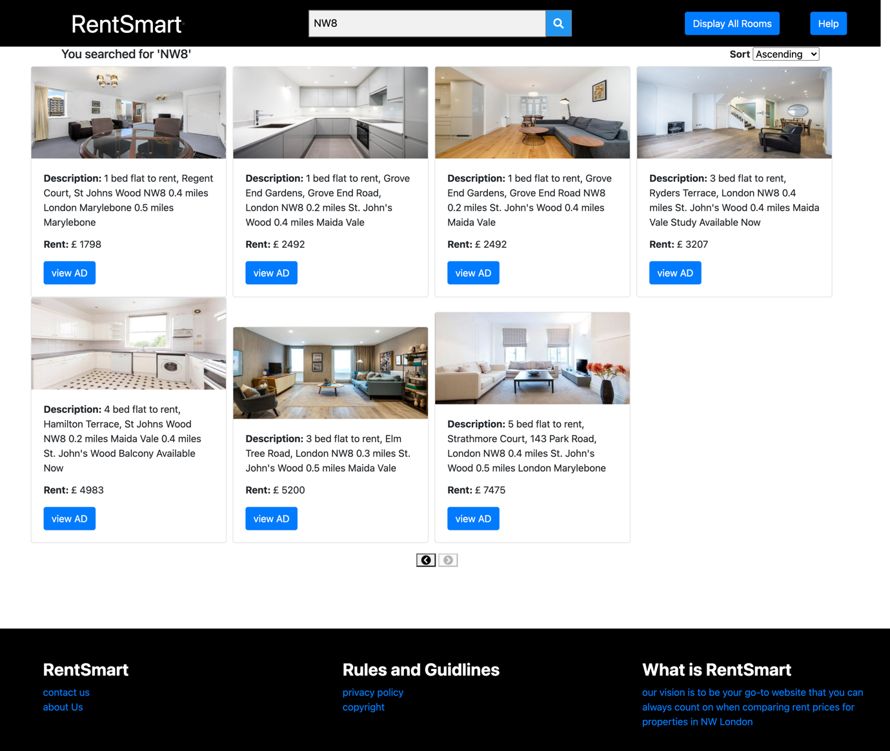

Click button ‘Display All Rooms’

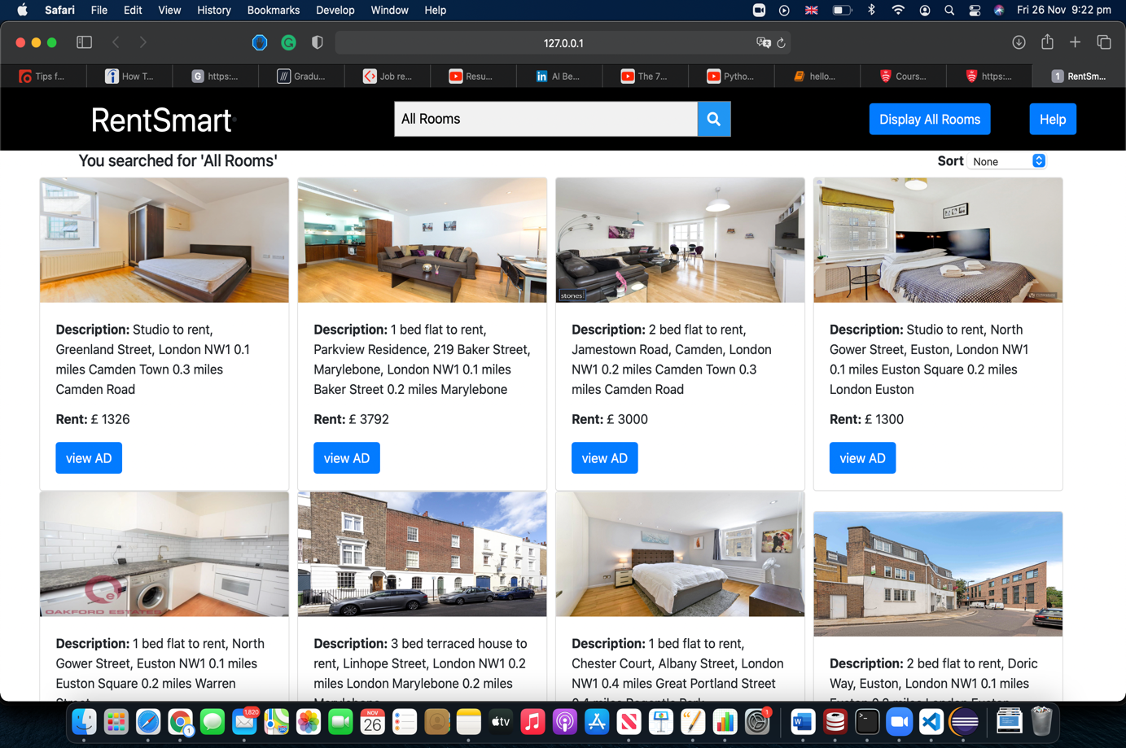

Unit tests

Java unit tests:

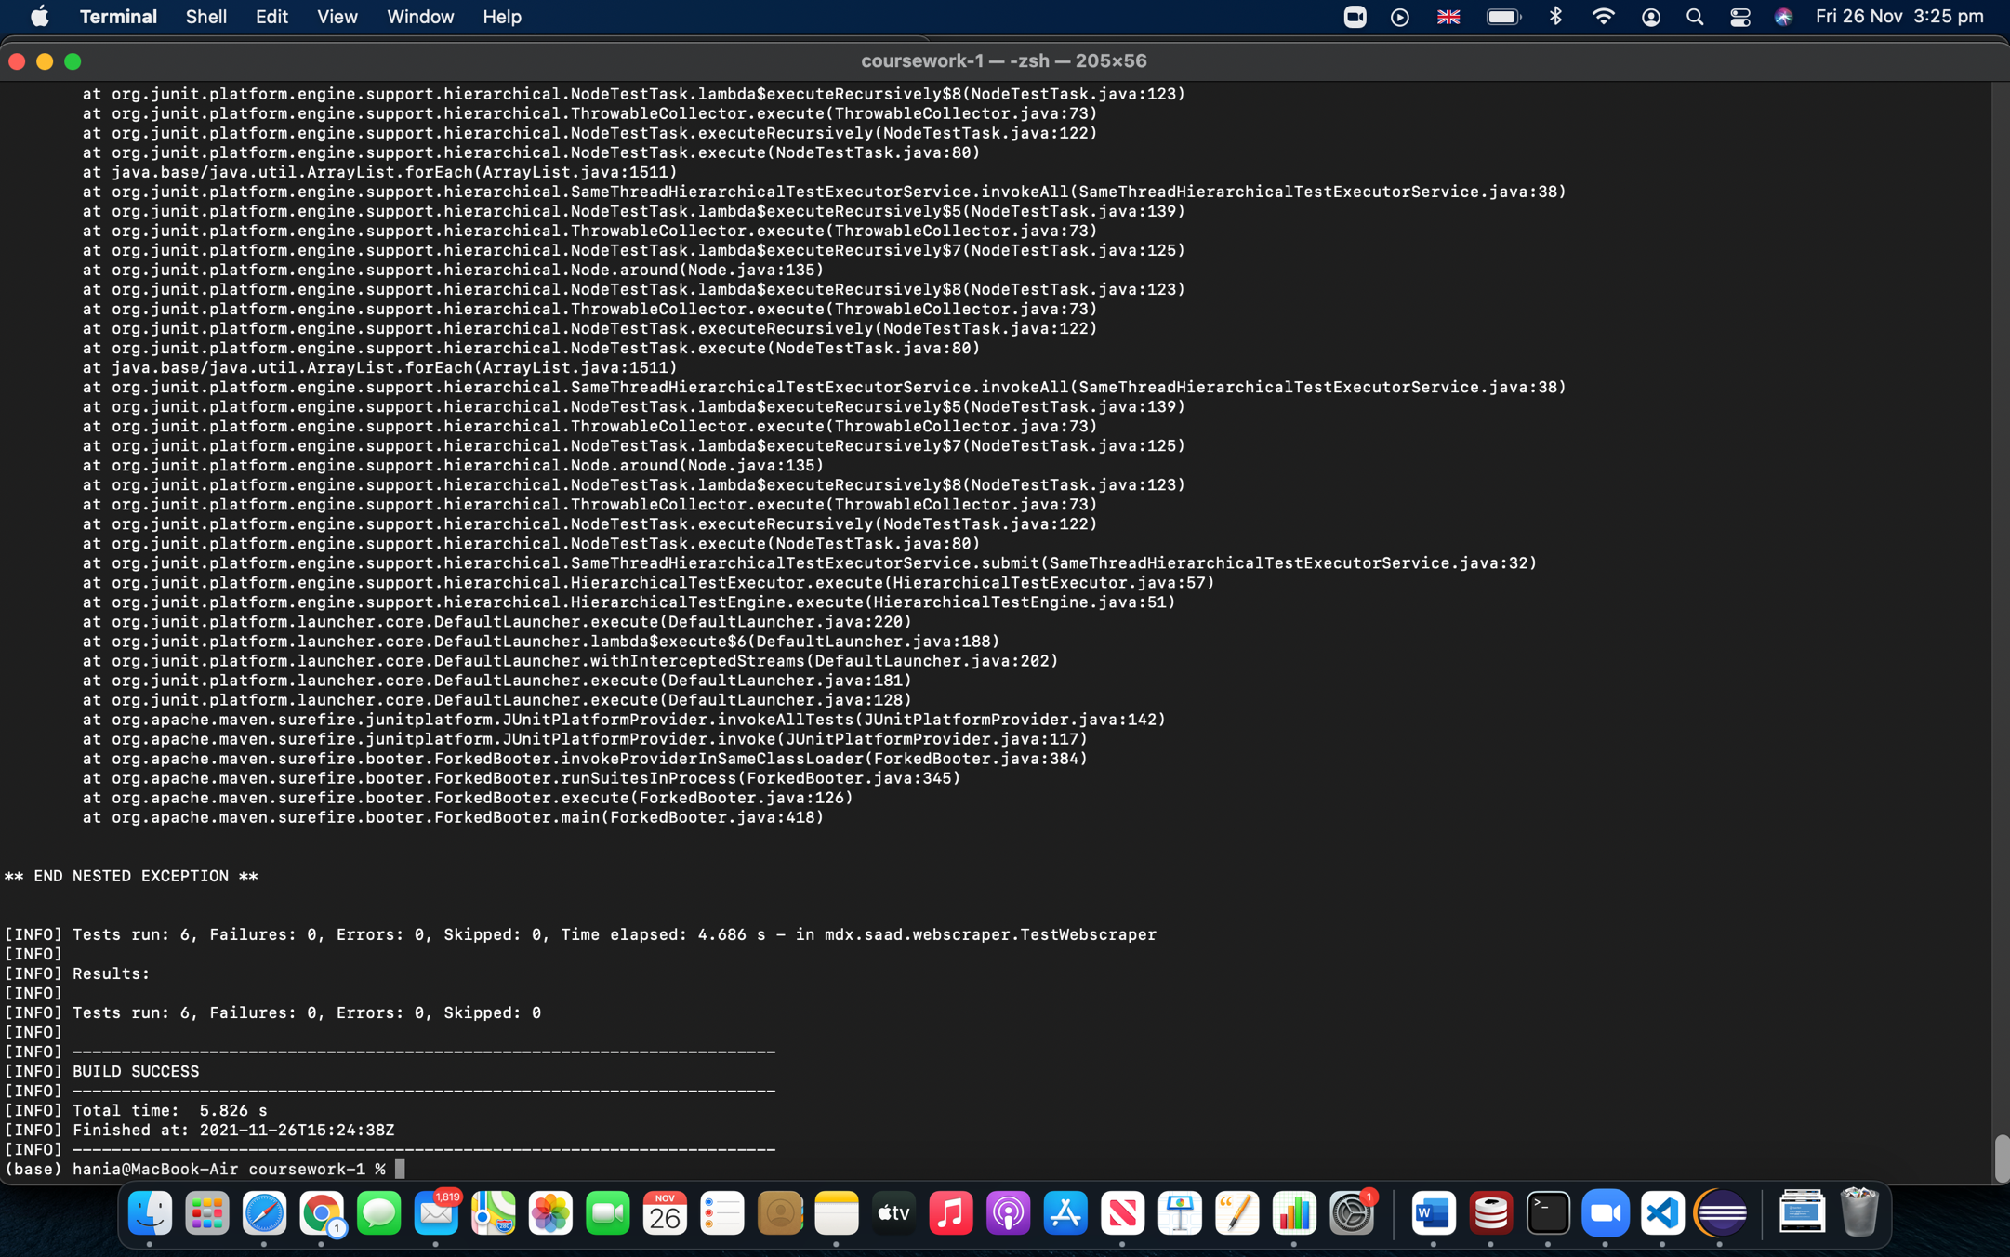

Java Script unit tests:

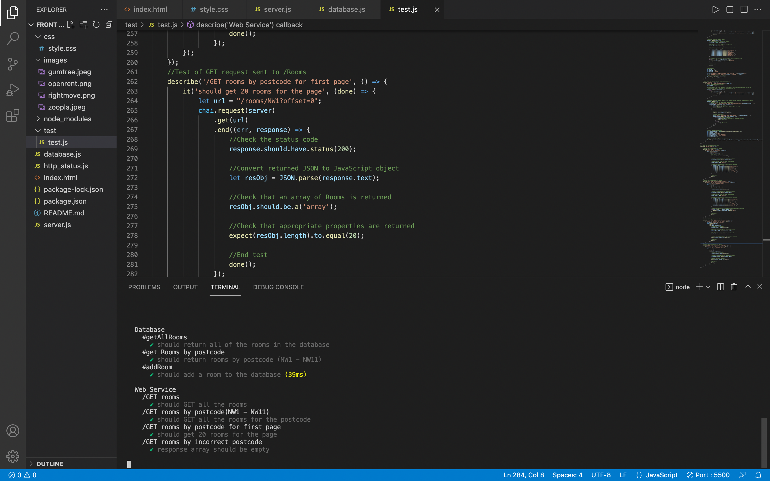

**Database Design**

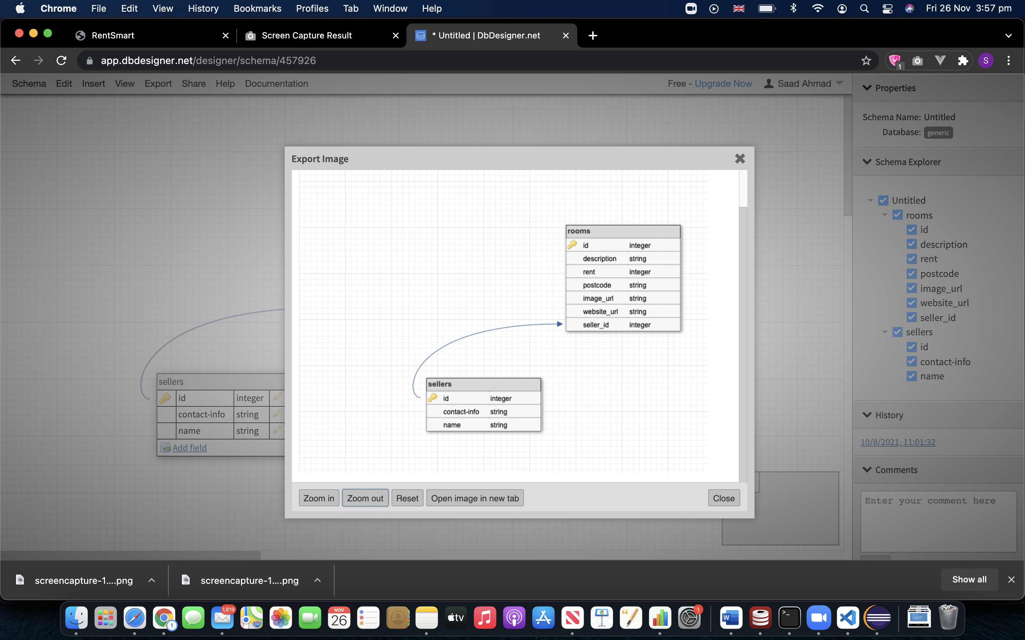

**Limitations:**

* The program couldn’t scrape the seller details for some of the websites as they were not displayed by the website page. In that case, the default value “none” is used.
* The website called ‘Zoopla’ was scraped earlier on in the progression of this project and later the developers of the website changed the HTML code. Due to this, seller details weren’t scraped from the website correctly as the foreign key functionality was implemented after Zoopla has already been scraped and its HTML code being changed. Therefore, I did not bother deleting and re-scraping data from Zoopla as I feared losing the stored data from this website.
* Scraping four websites for this project was approved by David Gamez and was mentioned in the project proposal as well.